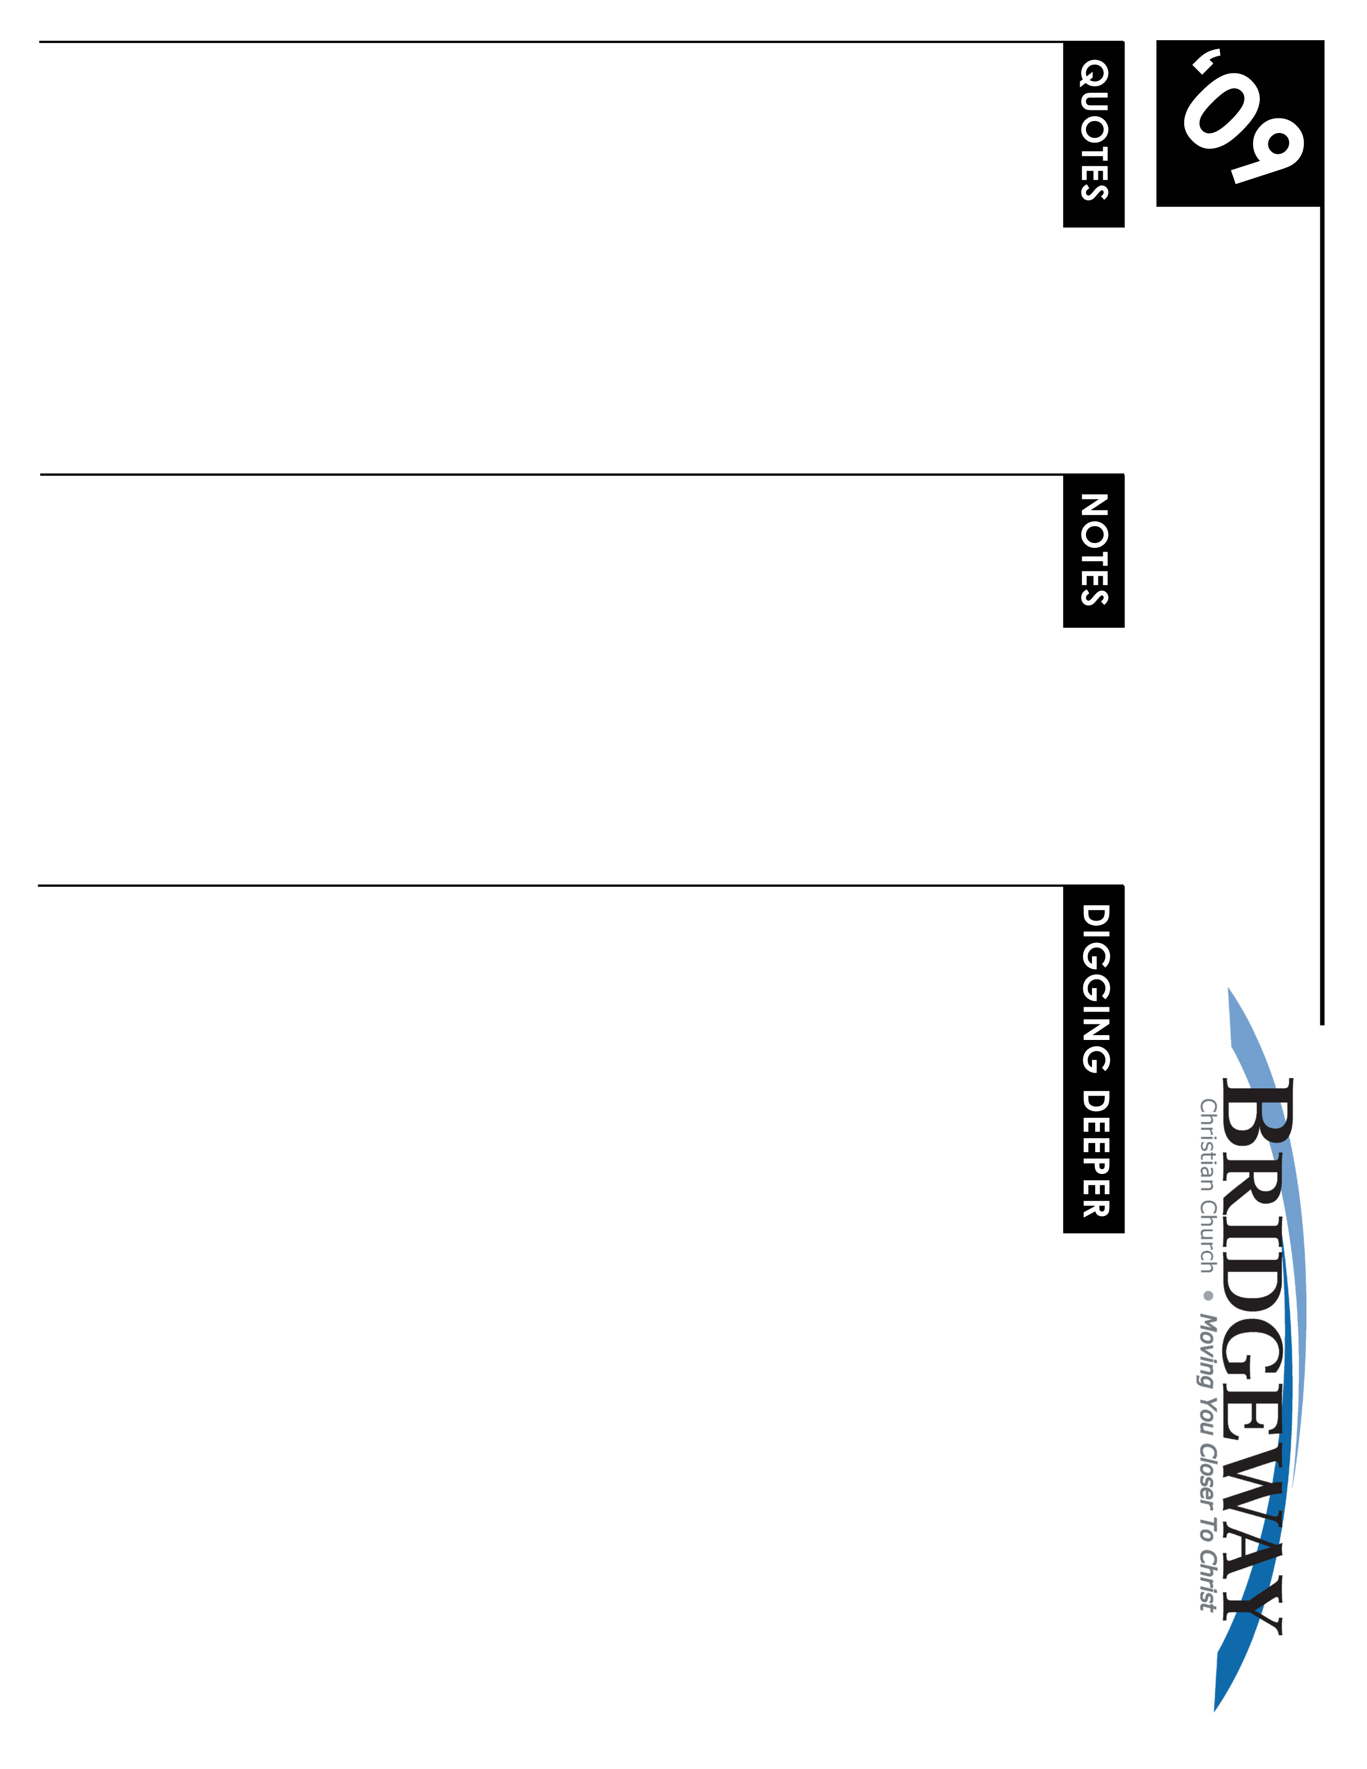
Here I Stand - Church History Series Pt. 2
1/31/09-2/1/09 -
The Reformation and the Worldwide Impact

“My conscience is a prisoner of God’s word. I cannot and will not recant, for to disobey one’s conscience is neither just nor safe. God help me. Amen.” Martin Luther, 1521

“If the inner man is such that he finds his delight in the law of God because he has been created in the divine image in order to have communion with Him, it follows that there will be no law or word which will delight that inner man more than the Word of God." Ulrich Zwingli

“Let us beware lest our words and thoughts go beyond what the Word of God tells us...We must leave to God His own knowledge,...and conceive Him as He makes Himself known to us, without attempting to discover anything about His nature apart from His Word.” John Calvin
Sometimes _____ Raises Up __________ To Say ________ is ________

Some Dates and Figures to Know for This Week

Background on the Reformation – 1400-1500 Paradigm Shift
4 Main Religious Shifts
- Papacy Wanes in Power
- Great Schism of the West
- Constantinople Falls to Islam
- Renaissance’s Humanism/Individualism Takes Hold
Erasmus of Rotterdam (1466-1536)
Martin Luther (1483-1546)
Ulrich Zwingli (1484-1531)
Anabaptists
John Calvin (1509-1564)
The Reformation Impact
- 4 Major Groups Emerge in North America
- Lutherans – Luther & Melancthon (Minnesota, Wisconsin & Dakotas)
- Reformed – Zwingli & John Calvin (Michigan & some South)
- Anabaptists – Mennonites & Amish (W. Pennsylvania & some South)
- Anglicans/Episcopalians – Kramer & Barns (New England Area)
Catholic Counter Reformation
- 1546 Council of Trent
The Great Divide – Theological Distinctions Between Traditional Catholic & Protestant Views

WHAT’S GOING ON
NEW TO BRIDGEWAY?
Welcome! We believe that you are here by God's direct invitation regardless of who invited you or how you found the church. And we believe that He brought you here to transform you. It's our goal to help make things clearer and to create an atmosphere of engagement with God and worship of the King of Kings! So, please, join us as we spend time with the Lord.

If you would like more information about Bridgeway, be sure to fill out the Welcome Cardin the seat pocket in front of you and drop it into the offering. We can send more info on who we are and how you can get involved.

Plus there’s always a ton of info on our website- including lessons, videos, announcements, and more! www.bridgewaychristian.org

INFORMATION

Kidsway Children’s Ministry is provided for all ages. Please visit the Welcome Center for more information and classroom locations.
CROWN FINANCIAL GROUPS
Sign-ups Start Jan. 24th in the lobby
The Biblical Financial Study is a 10-week study that teaches the successful combination of God’s wisdom along w/practical financial principles.
CHURCH OF THE WEEK w/LOVE INC.
March 16th – 21st Activities and ways to participate available soon. Contact Kim Turner for more details 916.223.2280

CONNECTIONS CLASS
Starts March 22nd at 9am in the Community Hall (new building). No registration needed.

MEMBERSHIP CLASS
May 3rd at 9:00am in the Community Hall (new building).

POPROCKS LAUNCH
Kidsway’s Poprocks will launch Wed. April 1st at 6:30pm.

JR HIGH WINTER CAMP - Feb. 27th – March 1st.
SR HIGH WINTER CAMP - Feb. 13th – Feb. 16th. Contact the Youth Dept. for details on how to sign up. 916.626.3050 ext. 231

NEXT NEWCOMERS DINNER
Friday March 20th at 6:30pm.

WOMEN’S SPRING RETREAT
April 24th – 26th. More details coming soon! Check out bridgewaychristian.org for the latest news!

SMALL GROUPS
Grow deeper with God & others…
Build a deeper relationship with God, experience significant growth in your spiritual life, and feel more a part of the church family - participate in a small group Bible study.

Pick up a Small Group Booklet in the lobby or check the church web site to see a list of groups.
FOR THE LATEST NEWS, EVENT DETAILS, MINISTRY INFO, SIGN-UPS, BLOGS, PODCASTS & MORE VISIT
www.BridgewayChristian.org
Bridgeway Christian Church, 3785 Placer Corporate Drive Suite 560, 95765, ph. (916) 626-3050
LIVEWIRE Jr. & Sr. High Ministry (6th – 12th grade) meets during all the services in the Youth Room

JR. HIGH’s THE EDGE (6th – 8th grade)
Every Wed. @ 6:30pm in the Youth Room

SR. HIGH’S REFUGE
Every Thurs. @ 7:00pm in the Youth Room

Crossroads young adult ministry
Meets every Sunday @ 6:00pm in the Sanctuary for dinner and worship together.

