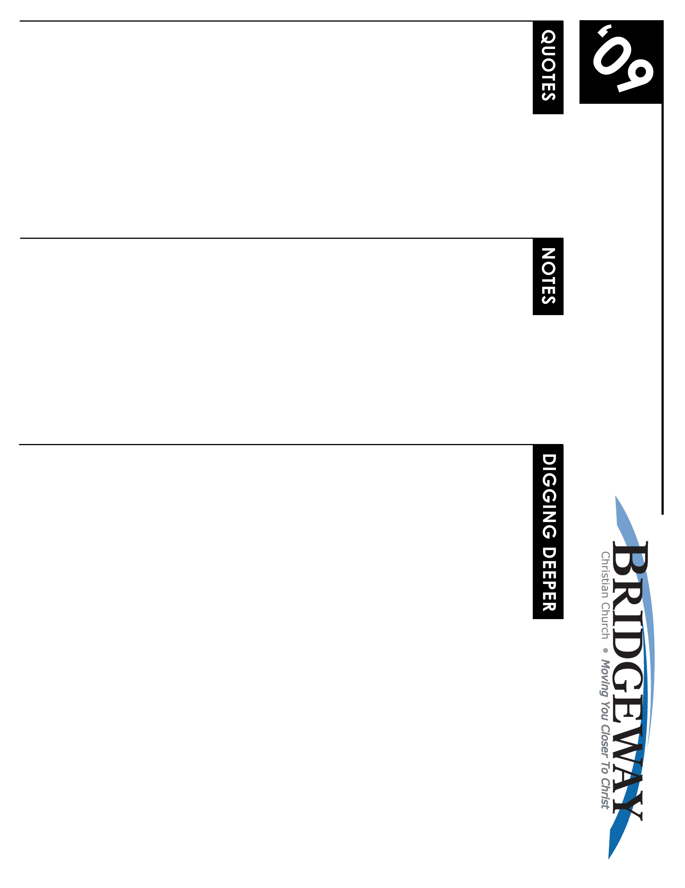
Thy Kingdoms Come
2/14/09-2/15/09 – Daniel chp. 2
The Statue Dream of Daniel

"How strange that all these cities and nations have perished. No voice could be more eloquent than that of those ruined cities and desolate kingdoms, testifying how fearful a thing it is to fall under the displeasure of God, and how certainly he will execute all his threatening." Mark Hopkins (Evidence of Christianity.)

"Babylon, once a world center of power and glory, is now a pile of dust and broken walls...Daniel knew this wicked city, so did Abraham. Here proud Nebuchadnezzar built his palace--before he was humbled to eat grass with the wild asses. Here came Alexander the Great, to die. Here Belshazzar held that famous feast where ‘they drank from golden vessels, as the Book of Truth records,' when the Hand came and wrote on the wall. Now the trains for Aasra whistle past on the track in the foreground, but there seems little to stop for. The Bible prophesies of its utter ruin have all come true." (Article on the Ancient Cit of Babylon - National Geographic, Dec 1938)
The ___________ is In God’s ________ ________

Questions for the Heart and Spirit
- Do you believe the prophecies of the Bible? All of them? If not, which would you eliminate?
- Do you believe that many of the Old Testament Prophecies have been fulfilled? Can you point out some that have been? Find one that has not been.
- Why are there Major and Minor prophets? What is the difference?
- What is the qualification for being a true Biblical Prophet? Find scripture that supports your argument. What happens to those who are not true prophets?

Questions for the Mind
- Read: Is 6:1-8; Jer 1:4-8; Ez 1:28-2:7; Dan 9:20-22
What was the defining characteristic of these four prophets? How did they become prophets? Who gave them their prophecies? Were they men of God before they became prophets?
- Read: Hag 1:1-2; Joel 1:1-3; Zech 1:1-4; Mal 1:1
How do these scriptures indicate these prophets were different than the four in question 1? Does that make them minor prophets? How did these prophets qualify to be prophets?
- Read: Ex 3:1-10; Ex 6:1-4; Ex 10: 1-4; Ex 19:3-6
Was Moses a prophet? Which of these scriptures indicate that Moses would qualify as a prophet? How does Moses differ from those prophets referenced in question 1 and 2?
- Read: Matt 1:22; 2:15,17,23; 4:14; 8:17; 12:17; 13:14; 13:35; 21:4 26:56
What do these verses have in common? What do they tell you about the prophecies of Isaiah and Jeremiah? Why do you think Matthew refers to the fulfillment of Old Testament prophecies so many times?
- Read: Ezekial 36:22-38 Do you think this is a prophecy of the establishment of the state of Israel in 1948? What is contained in this scripture that would lead you to believe so? Or not? Read the surrounding context. Now what do you think?
Application
- Read the book of Haggai, then Ezra 4:22-6:16 for the fulfillment.

WHAT’S GOING ON
NEW TO BRIDGEWAY?
Welcome! We believe that you are here by God's direct invitation regardless of who invited you or how you found the church. And we believe that He brought you here to transform you. It's our goal to help make things clearer and to create an atmosphere of engagement with God and worship of the King of Kings! So, please, join us as we spend time with the Lord.

If you would like more information about Bridgeway, be sure to fill out the Welcome Cardin the seat pocket in front of you and drop it into the offering. We can send more info on who we are and how you can get involved.

Plus there’s always a ton of info on our website- including lessons, videos, announcements, and more! www.bridgewaychristian.org

INFORMATION

Kidsway Children’s Ministry is provided for all ages. Please visit the Welcome Center for more information and classroom locations.
CROWN FINANCIAL GROUPS
Sign-ups Start Jan. 24th in the lobby
The Biblical Financial Study is a 10-week study that teaches the successful combination of God’s wisdom along w/practical financial principles.
CHURCH OF THE WEEK w/LOVE INC.
March 16th – 21st Activities and ways to participate available soon. Contact Kim Turner for more details 916.223.2280

CONNECTIONS CLASS
Starts March 22nd at 9am in the Community Hall (new building). No registration needed.

MEMBERSHIP CLASS
May 3rd at 9:00am in the Community Hall (new building).

POPROCKS LAUNCH
Kidsway’s Poprocks will launch Wed. April 1st at 6:30pm.

JR HIGH WINTER CAMP - Feb. 27th – March 1st.
SR HIGH WINTER CAMP - Feb. 13th – Feb. 16th. Contact the Youth Dept. for details on how to sign up. 916.626.3050 ext. 231

NEXT NEWCOMERS DINNER
Friday March 20th at 6:30pm.

WOMEN’S SPRING RETREAT
April 24th – 26th. More details coming soon! Check out bridgewaychristian.org for the latest news!

SMALL GROUPS
Grow deeper with God & others…
Build a deeper relationship with God, experience significant growth in your spiritual life, and feel more a part of the church family - participate in a small group Bible study.

Pick up a Small Group Booklet in the lobby or check the church web site to see a list of groups.
FOR THE LATEST NEWS, EVENT DETAILS, MINISTRY INFO, SIGN-UPS, BLOGS, PODCASTS & MORE VISIT
www.BridgewayChristian.org
Bridgeway Christian Church, 3785 Placer Corporate Drive Suite 560, 95765, ph. (916) 626-3050
LIVEWIRE Jr. & Sr. High Ministry (6th – 12th grade) meets during all the services in the Youth Room

JR. HIGH’s THE EDGE (6th – 8th grade)
Every Wed. @ 6:30pm in the Youth Room

SR. HIGH’S REFUGE
Every Thurs. @ 7:00pm in the Youth Room

Crossroads young adult ministry
Meets every Sunday @ 6:00pm in the Sanctuary for dinner and worship together.

